Name, Vorname: | […]
geb.: | […]
Unfalltag: | […]
Anlage zum D-Bericht Nr.: |  |  | […]
Ergänzungsbericht – schwere Verbrennungen -
Verbrennung |  | 1 Jahr |  | 1 bis 4  Jahre |  | 5 bis 9  Jahre | 10 bis 14  Jahre | 15  Jahre | Erwachsene | 2°-A*) | 2°-B*) | 3°*) | 4°*)
Kopf |  | 19 |  | 17 |  | 13 | 11 | 9 | 7 | […] | […] | […] | […]
Hals |  | 2 |  | 2 |  | 2 | 2 | 2 | 2 | […] | […] | […] | […]
Rumpf (vorn) |  | 13 |  | 13 |  | 13 | 13 | 13 | 13 | […] | […] | […] | […]
Rumpf (hinten) |  | 13 |  | 13 |  | 13 | 13 | 13 | 13 | […] | […] | […] | […]
Rechte Gesäßhälfte |  | 2 ½ |  | 2 ½ |  | 2 ½ | 2 ½ | 2 ½ | 2 ½ | […] | […] | […] | […]
Linke Gesäßhälfte |  | 2 ½ |  | 2 ½ |  | 2 ½ | 2 ½ | 2 ½ | 2 ½ | […] | […] | […] | […]
Genitalien |  | 1 |  | 1 |  | 1 | 1 | 1 | 1 | […] | […] | […] | […]
Rechter Oberarm |  | 4 |  | 4 |  | 4 | 4 | 4 | 4 | […] | […] | […] | […]
Linker Oberarm |  | 4 |  | 4 |  | 4 | 4 | 4 | 4 | […] | […] | […] | […]
Rechter Unterarm |  | 3 |  | 3 |  | 3 | 3 | 3 | 3 | […] | […] | […] | […]
Linker Unterarm |  | 3 |  | 3 |  | 3 | 3 | 3 | 3 | […] | […] | […] | […]
Rechte Hand |  | 2 ½ |  | 2 ½ |  | 2 ½ | 2 ½ | 2 ½ | 2 ½ | […] | […] | […] | […]
Linke Hand |  | 2 ½ |  | 2 ½ |  | 2 ½ | 2 ½ | 2 ½ | 2 ½ | […] | […] | […] | […]
Rechter Oberschenkel |  | 5 ½ |  | 6 ½ |  | 8 | 8 ½ | 9 | 9 ½ | […] | […] | […] | […]
Linker Oberschenkel |  | 5 ½ |  | 6 ½ |  | 8 | 8 ½ | 9 | 9 ½ | […] | […] | […] | […]
Rechter Unterschenkel |  | 5 |  | 5 |  | 5 ½ | 6 | 6 ½ | 7 | […] | […] | […] | […]
Linker Unterschenkel |  | 5 |  | 5 |  | 5 ½ | 6 | 6 ½ | 7 | […] | […] | […] | […]
Rechter Fuß |  | 3 ½ |  | 3 ½ |  | 3 ½ | 3 ½ | 3 ½ | 3 ½ | […] | […] | […] | […]
Linker Fuß |  | 3 ½ |  | 3 ½ |  | 3 ½ | 3 ½ | 3 ½ | 3 ½ | […] | […] | […] | […]
Summe: |  |  |  |  |  |  |  |  |  | […] | […] | […] | […]
Gesamtverbrennung: |  |  |  |  |  |  |  |  |  | […]
 |  |  |  |  |  |  |  |  |  | *) Ausmaß und Schweregrad der Verbrennungen in entsprechende Spalte eintragen.

ABSI-Score

Parameter | Punkte | Summe Punkte | % verbrannte KOF | Punkte | Summe Punkte
 |  |  |  |  | Übertrag: | […]
Mann | 0 | […] | 1- 10 | 1 | […]
Frau | 1 | […] | 11- 20 | 2 | […]
Alter: |  | […] | 21- 30 | 3 | […]
0-20 | 1 | […] | 31- 40 | 4 | […]
21-40 | 2 | […] | 41- 50 | 5 | […]
41-60 | 3 | […] | 51- 60 | 6 | […]
61-80 | 4 | […] | 61- 70 | 7 | […]
> 80 | 5 | […] | 71- 80 | 8 | […]
Inhal. Trauma | 1 | […] | 81- 90 | 9 | […]
Drittgradige | 1 | […] | 91-100 | 10 | […]
Übertrag: |  | […] | Gesamtpunktzahl: |  | […]

Gesamtpunktzahl | Sterbewahrscheinlichkeit
2 - 3 | < 1 %
4 - 5 | 2 %
6 - 7 | 10-20 %
8 - 9 | 30-50 %
10 -11 | 60-80 %

Datenschutz:
Ich habe die Hinweise nach § 201 SGB VII gegeben.
Datum | Name und Anschrift der Durchgangsärztin/des Durchgangsarztes
[…] | […]

Sie erhalten eine Gebühr nach Nr. 139 UV-GOÄ

Name, Vorname: | […]

Beiblatt schwere Verbrennungen am […]

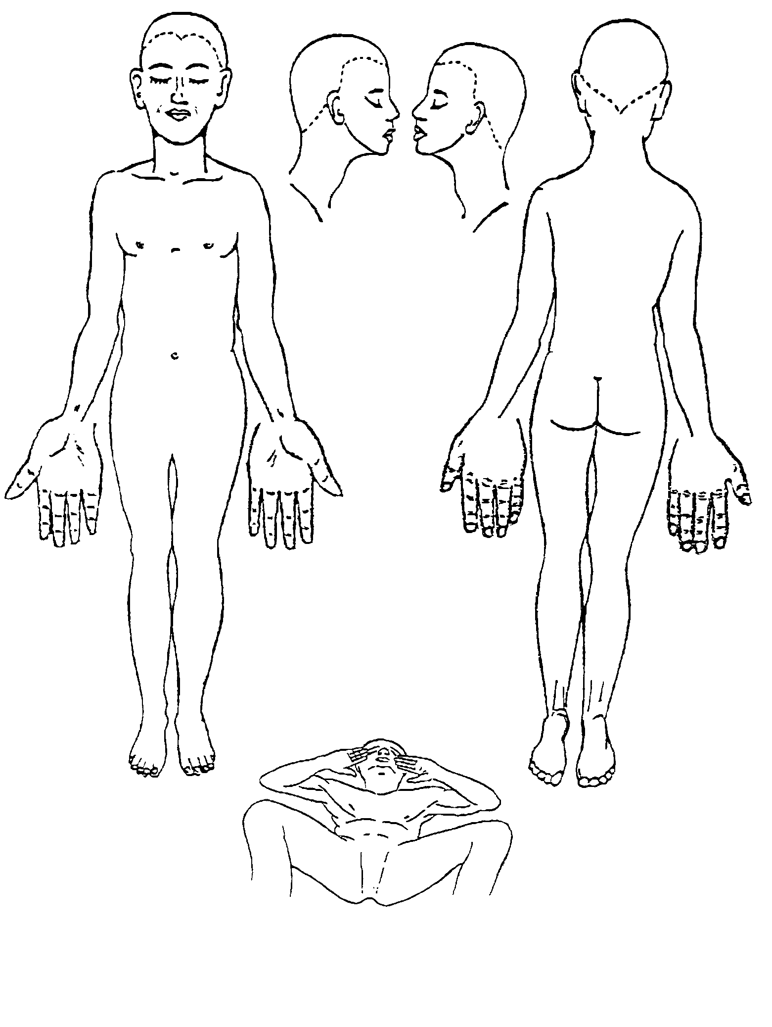
Farbschema

2°-A = blau*)
2°-B = blau-rot-gestreift
3° = rot*)
4° = schwarz*)
*) in Skizze eintragen

