Name: […] Aktenzeichen: […]
Untersuchungstag: […]
☐ Rechtshänder | ☐ Linkshänder
Messblatt Finger (nach der Neutral - 0 - Methode)
A. Streckung / Beugung |  |  | Daumen |  |  |  |  |  |  |  |  |  |  |  |  | 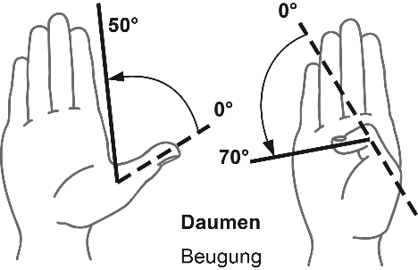  Abb. 1 a Abb. 1 b
 |  |  | Rechts |  |  |  |  | Links
Grundgelenk (Abb. 1 a) |  |  | […] |  | […] |  | […] | […] |  | […] |  | […]
Endgelenk (Abb. 1 b) |  |  | […] |  | […] |  | […] | […] |  | […] |  | […]
Abspreizung (Winkel zwischen 1. und 2. Mittelhandknochen |  |  | Rechts |  |  |  |  | Links |  |  |  |  |  |  |  | 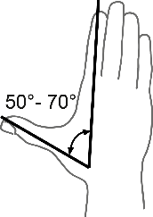  Abb. 2 |  | 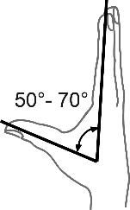  Abb. 3
in der Handebene (Abb. 2) |  |  | 0 |  | […] |  | […] | 0 |  | […] |  | […]
rechtwinklig zur Handebene (Abb. 3) |  |  | 0 |  | […] |  | […] | 0 |  | […] |  | […]
B. Streckung / Beugung (Abb. 4 bis 6) |  |  | Langfinger
 |  |  | Rechts |  |  |  |  | Links |  |  |  |  |  |  |  | 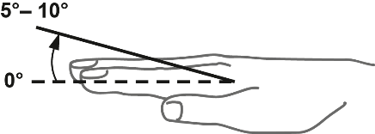  Streckung Grundgelenk  Abb. 4
II. Grundgelenk Zeigefinger |  |  | […] |  | […] |  | […] | […] |  | […] |  | […]
II. Mittelgelenk Zeigefinger |  |  | […] |  | […] |  | […] | […] |  | […] |  | […]
II. Endgelenk Zeigefinger |  |  | […] |  | […] |  | […] | […] |  | […] |  | […]
 |  |  | Rechts |  |  |  |  | Links |  |  |  |  |  |  |  | 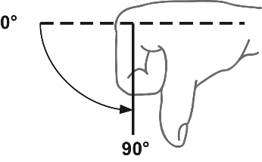  Beugung Grundgelenk  Abb. 5  Beugung Mittelgelenk Endgelenk
III. Grundgelenk Mittelfinger |  |  | […] |  | […] |  | […] | […] |  | […] |  | […]
III. Mittelgelenk Mittelfinger |  |  | […] |  | […] |  | […] | […] |  | […] |  | […]
III. Endgelenk Mittelfinger |  |  | […] |  | […] |  | […] | […] |  | […] |  | […]
 |  |  | Rechts |  |  |  |  | Links
IV. Grundgelenk Ringfinger |  |  | […] |  | […] |  | […] | […] |  | […] |  | […] |  |  |  | 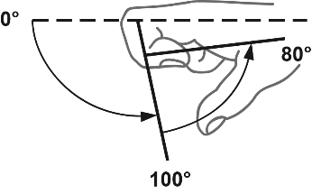
IV. Mittelgelenk Ringfinger |  |  | […] |  | […] |  | […] | […] |  | […] |  | […]
IV. Endgelenk Ringfinger |  |  | […] |  | […] |  | […] | […] |  | […] |  | […]
 |  |  | Rechts |  |  |  |  | Links
V. Grundgelenk Kleiner Finger |  |  | […] |  | […] |  | […] | […] |  | […] |  | […]
V. Mittelgelenk Kleiner Finger |  |  | […] |  | […] |  | […] | […] |  | […] |  | […] |  |  |  | Abb. 6
V. Endgelenk Kleiner Finger |  |  | […] |  | […] |  | […] | […] |  | […] |  | […]
C. Abstand Fingerkuppen | II. | III. |  | IV. |  | V. |  |  | II. |  | III. |  | IV. |  | V. |  | 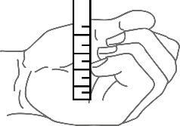Abb. 7  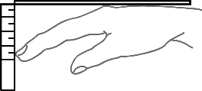  Abb. 8
von der queren Hohlhandbeugefalte in cm  (Abb. 7) | […] | […] |  | […] |  | […] |  |  | […] |  | […] |  | […] |  | […]
von der verlängerten  Handrückenebene in cm  (Abb. 8) | […] | […] |  | […] |  | […] |  |  | […] |  | […] |  | […] |  | […]
Ankreuzen, welche Langfingerkuppen mit der Daumenspitze erreicht werden können | […] | […] |  | […] |  | […] |  |  | […] |  | […] |  | […] |  | […]

